TITLE (upper case)
N. Lastname¹, N. Lastname² & N. Lastname3

Affiliation, city of affiliation, country, email address
² Affiliation, city of affiliation, country
³ Affiliation, city of affiliation, country

Abstract: If the title, authors and abstract included here feature changes or corrections with respect to what had been indicated in the initial abstract submission, then such details should also be updated on the WCEE2024 online paper submission platform. It is also recalled that the abstract should not exceed 2500 characters (including spaces), and should here be preceded by a 24 point paragraph spacing.

General considerations
The proceedings of the 18th World Conference on Earthquake Engineering will consist of a collection of Portable Document Format (PDF) conference papers, which will be rendered available online at the IAEE platform, and will also be indexed in typical publications databases (if the number of pages exceeds the minimum of 8).
Papers to be submitted to the 18th World Conference on Earthquake Engineering (WCEE2024) should thus be drafted following the structure and style of this Word document, and subsequently transformed into a Portable Document Format (PDF) file before their uploading onto the paper submission platform indicated on this webpage, within the deadline of 15th October 2024.
Please note that, in order to be able to submit the paper, you will need to first carry out the pre-registration to the conference, using one of the different payment methods available at the submission platform. Please do undertake the pre-registration payment well in advance of the above deadline, especially if you chose to carry out the payment through bank transfer, which can take several days to complete.

Style guidance

WCEE2024 Styles
This template is formatted to resemble a final paper. The template contains a number of styles named “WCEE2024 Body text”, “Heading 1,WCEE2024 H1”, “WCEE2024 Caption”, etc. The use of WCEE2024 styles ensures that the final paper complies with the guidelines contained herein. The base font for all styles is Arial.

Paper header
The title of the paper should be centred using bold upper case 13 point all capital font with 78 point spacing above and 12 point spacing below. Authors’ full names should also be centred in 11 point font. The affiliation and email address of the corresponding author should be given separately on the first page. The affiliations of other authors may also be given. Please note that, in-line with general data protection regulations, the email addresses of other authors should not be included in this public document.

Headings

Heading 3
Three heading styles are predefined within this template (“Heading 1,WCEE2024 H1”, “Heading 2,WCEE2024 H2” and “Heading 3,WCEE2024 H3). Other subheadings should not be used within the paper.

Body text of the paper
Paragraphs should be written in the “WCEE2024 Body text” style. The style is defined by 1.1 line spacing with 10 point font (justified) and 6 point spacing between each paragraph.
Carriage returns (blank lines) should not be added between the section headings and the body text, or between individual paragraphs. A single space should be used between sentences.
- This is an example of a bullet list.
- Second line in bullet list.
- Third line in bullet list.
- This is an example of a numbered list.
- Second line in numbered list.
- Third line in numbered list

Copyright
It is the responsibility of the authors to obtain permissions to reproduce material obtained from other publications (if permission is required under copyright law). In submitting the paper to the conference, the author(s) give permission that IAEE may publish the paper online and on electronic media such as USB memory sticks.

Page count and file size
Papers should not be lengthier than 12 pages (including figures, tables and references). Shorter papers are accepted, with the caveat, however, that only papers featuring with 8 pages or more will be considered for possible indexing in publication databases. The file size should not exceed 20MB when in pdf format.

Figures
Figures should be numbered in sequence. Figures should be centred using the “WCEE2024 Figure” style, and the figure should be positioned ‘in line with text’ using Layout Options. A “WCEE2024 blank line” may be inserted before the figure to increase the spacing between body text and the figure. Figure captions should be written in the “WCEE2024 Figure Caption” style and be centred beneath each figure. Acknowledgements should be made if the figure is reproduced (with permission) from any other publication in brackets at the end of the caption. Axes should be clearly defined; the usage of symbols as axis labels should be avoided unless the symbols are defined in the main text. Units should be indicated on the axis labels. The legend and axes descriptions should be read easily with at least 10 point font (preferably Arial).

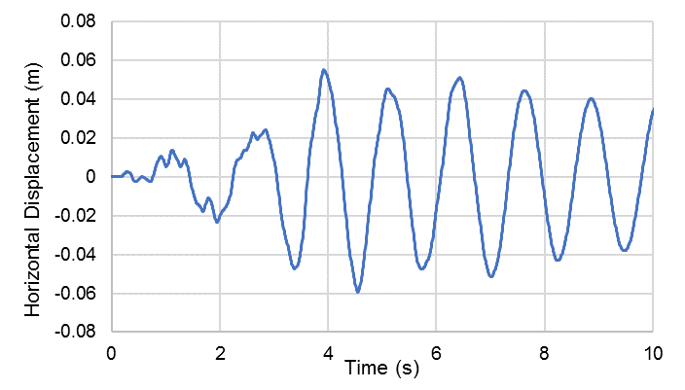
Figure 1. Figure caption here.

Tables
Table should be numbered in sequences. A “WCEE2024 blank line” may be inserted before the table to increase the spacing between body text and the table. The following table shows an example. If tables span multiple pages, the heading row should be repeated at the top of each page.

Table 1. Table caption here.

Table heading | Table heading | Table heading
Tables should be numbered in sequence. Each table should be mentioned in the text before the table is placed | Table captions should be based on the “WCEE2024 Table Caption” style. | Table text should be Arial font, at least 9 points, but preferably 10 points.
Tables should be centred, and the table size should not exceed page margins. | A “WCEE2024 blank line” may be inserted before the table to increase the spacing between body text and table. | Acknowledgements should be made if the table is quoted from any other publication, with the citation placed in brackets at the end of the caption.

Equations and math
Equations should be formatted by means of MathType Equation Editor or the inbuilt Microsoft Equation Editor. Equations should be centred and numbered consecutively.
With MathType Equation Editor: On a new line, select the “WCEE2024 Equation” style and press tab once; type the equation, and press tab again; then type the equation number. Equation numbers should be placed at the right end of the equation line between parentheses. For example:
(1)
With Microsoft Equation Editor: On a new line, select the “WCEE2024 Body text” style and insert a table with one row and three columns. The 1st and the 3rd column should be of equal width. Leave the first cell blank. Insert the equation in the second cell, with centred alignment. Insert the equation number in the third cell with right alignment. Under Table Design, choose No Borders for the whole table. For example:
 | $${\text{C}}_{\text{SR}} \text{=} \text{0.65}\frac{{\text{a}}_{\text{max}}}{\text{g}}\frac{{\text{σ}}_{\text{v}}}{{\text{σ}}_{\text{v}}^{\text{'}}}{\text{r}}_{\text{d}}$$ | (2)
The equation should be written in 10 point Arial or Cambria Math using italics for Latin symbols and normal (upright) font for Greek symbols and numbers. All symbols should be defined within the text.

References
References should follow the Harvard style, also known as the "author-date" style. A reference within the text is given as, for example, Clough and Penzien (1993). References should be listed in alphabetical order at the end of the paper. Some examples are shown below for a standard, a textbook, a conference paper, and a journal paper.
CEN (2005). EN 1998-3:2005. Eurocode 8: Design of structures for earthquake resistance - Part 3: Assessment and retrofitting of buildings, Comité Européen de Normalisation, Brussels.
Clough R.W., Penzien J. (1993). Dynamics of Structures, 2nd Ed., New York: McGraw-Hill Book Company
Freeman S.A. (1998). The Capacity Spectrum Method as a tool for seismic design”, Proceedings of the 11th European Conference on Earthquake Engineering, Paris, France.
Mander J.B., Priestley M.J.N., Park R. (1988). Theoretical stress-strain model for confined concrete, ASCE Journal of Structural Engineering, 114(8): 1804-1826.

